

**Course Name: Probability and Statistics**

**Topic: Daily Study Hours of UCU Students**

**Department of Computing & Technology Semester: Advent 2025**

**OBJECTIVES**

* To design and execute a field data collection exercise on student study habits.
* To organize and summarize both grouped and ungrouped data.
* To compute descriptive statistics such as mean, median, and standard deviation.
* To visualize findings using statistical software (Excel and Python).
* To write and present a well-structured scientific report.

**METHODOLOGY**

The study was conducted using a structured questionnaire distributed to a random sample of 63 UCU students. The population consisted of available students we reached out on campus in various places such as dining hall, computer labs,halls and hostels to mention but a few. Data was collected through face-to-face interaction. We were able to reach out to students in various courses such as Law,BSIT,BSCS,BSDC and Civil Engineering among others.

Each respondent provided details such as gender, course, and daily study hours. Quantitative data (study hours) were analyzed using Excel to obtain descriptive statistics. Ethical considerations such as consent and confidentiality were observed throughout the process.

According to the questioner we were able to come up with 10 coloumns which included the student name, age, gender , course, time-of-study(morning, afternoon or evening or mixed) etc

Other columns were question and answer format (YES or NO) ie weather they use the library to study or not a student was supposes to select YES or NO.

We also included a column where students would tell us what factors affect their time of study.

|  |  |  |  |  |  |
| --- | --- | --- | --- | --- | --- |
|  |  |  |  |  |  |
|  |  |  |  |  |  |
|  |  |  |  |  |  |
|  |  |  |  |  |  |

**UNGROUPED DATA FOR HOURS SPENT IN STUDIES PER DAY.**

|  |  |
| --- | --- |
| **Study Hours(Per Day)** | **Frequency** |
| 1 | 2 |
| 2 | 4 |
| 3 | 3 |
| 4 | 10 |
| 5 | 6 |
| 6 | 3 |
| 7 | 3 |
| 8 | 8 |
| 10 | 4 |
| 12 | 4 |
| 14 | 2 |
| 15 | 2 |
| 16 | 1 |
| 18 | 2 |

**GROUPED DATA**

|  |  |  |  |  |  |
| --- | --- | --- | --- | --- | --- |
| **CLASS INTERVAL (HRS.)** | **FREQUENCY** | **MIDPOINT(X)** | **CUMULATIVE FREQUENCY** | **Fx** | **Fx2** |
| 0-1.99 | 2 | 1.0 | 2 | 2 | 2 |
| 2-3.99 | 7 | 3.0 | 9 | 21 | 63 |
| 3-5.99 | 16 | 5.0 | 25 | 80 | 400 |
| 6-7.99 | 6 | 7.0 | 31 | 42 | 294 |
| 8-99.9 | 8 | 9.0 | 39 | 72 | 648 |
| 10-11.99 | 4 | 11.0 | 43 | 44 | 484 |
| 12-13.99 | 4 | 13.0 | 47 | 52 | 676 |
| 14-15.99 | 4 | 15.0 | 51 | 60 | 900 |
| 16-17.99 | 1 | 17.0 | 52 | 17 | 289 |
| 18-19.99 | 2 | 19.0 | 54 | 38 | 722 |
| Totals | 54 |  |  | 428 | 4478 |

**Descriptive Statistics for Grouped Data**

**Grouped Frequency Distribution**

|  |  |  |  |
| --- | --- | --- | --- |
| STATISTIC | FORMULA | VALUE | INTERPRETATION |
| Mean | Σfx / Σf | 428 / 54 = **7.93 hrs** | On average, a UCU student studies about **8 hours**  **per day** |
| Median | L + ((N/2 - CFbefore) / fm) × c | = 6 + ((27 - 25)/6)×2 = **6.67hrs** | The middle 50% of students study around **6–7 hours**  **daily** |
| Mode | L + ((fm - f1) / (2fm - f1 - f2)) × c | = 4 + ((16−7) / (32−7−6)) ×2 ≈ **4.95 hr** | The most common study duration is **about 5 hours**  **per day** |
| Range | Highest − Lowest | 19 − 1 = **18 hrs** | Indicates wide variation in study habits |
| **Variance (s²)** | (Σfx² / N) − (x̄)² | =(4478 / 54) − (7.93)²  = 82.92 − 62.88 = **20.04** | Shows data spread |
| **Standard Deviation (s)** | √Variance | √20.04 = **4.48 hrs** | On Average, a typical UCU student’s daily study hours is approximately 4.84 hours. |

**SCALE**

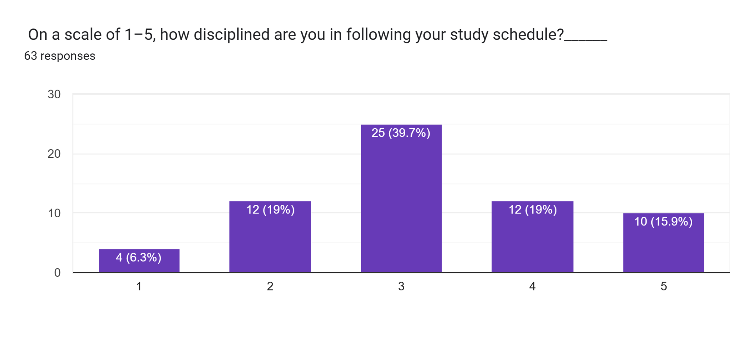

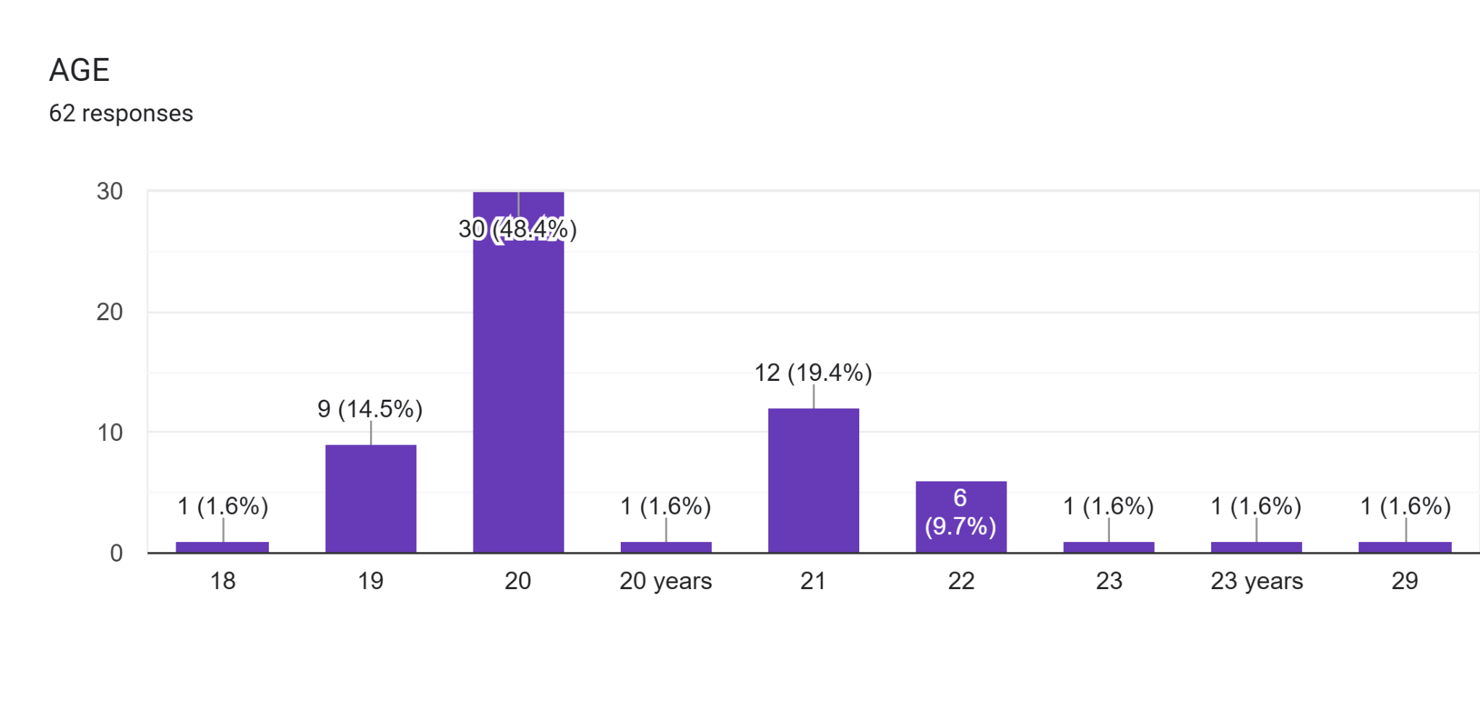

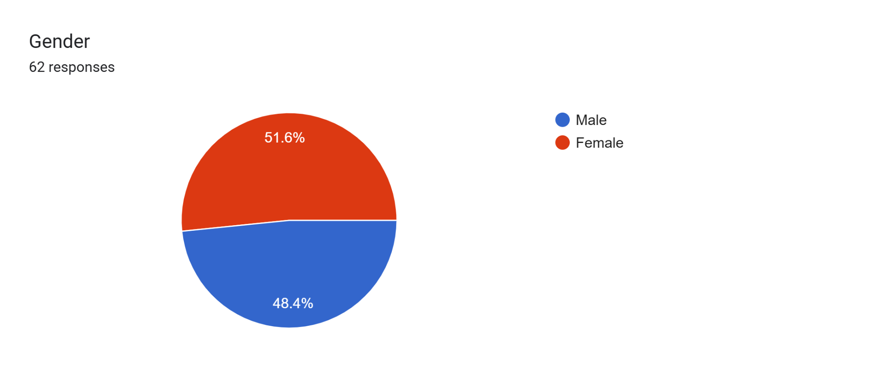

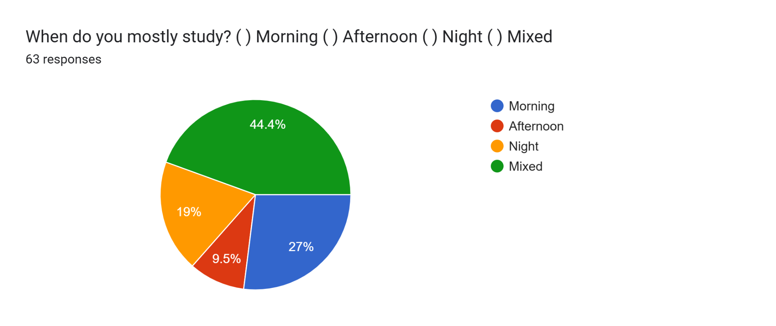

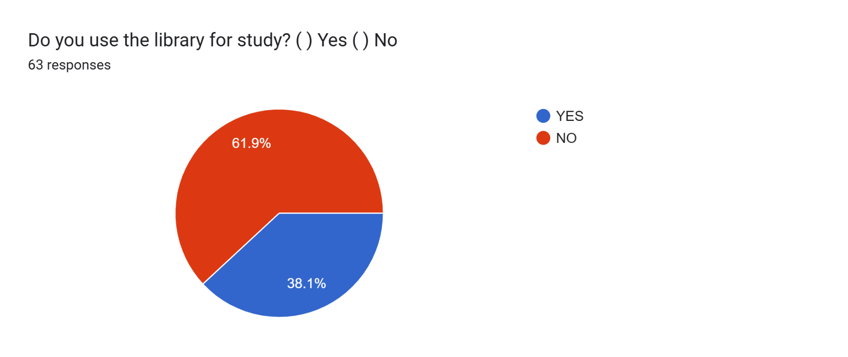

**IMAGES SHOWING OUR GROUP COLLECTING DATA USING THE QUESTIONNAIRE PAPER**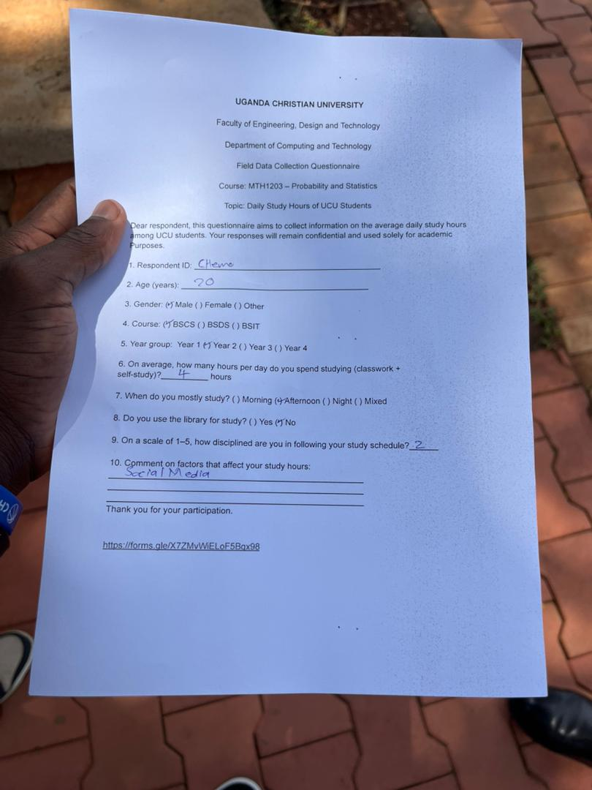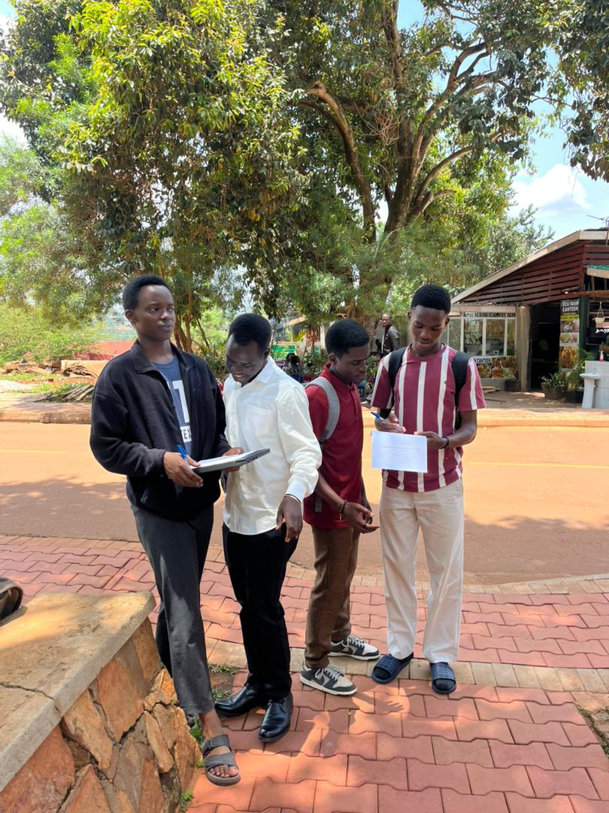

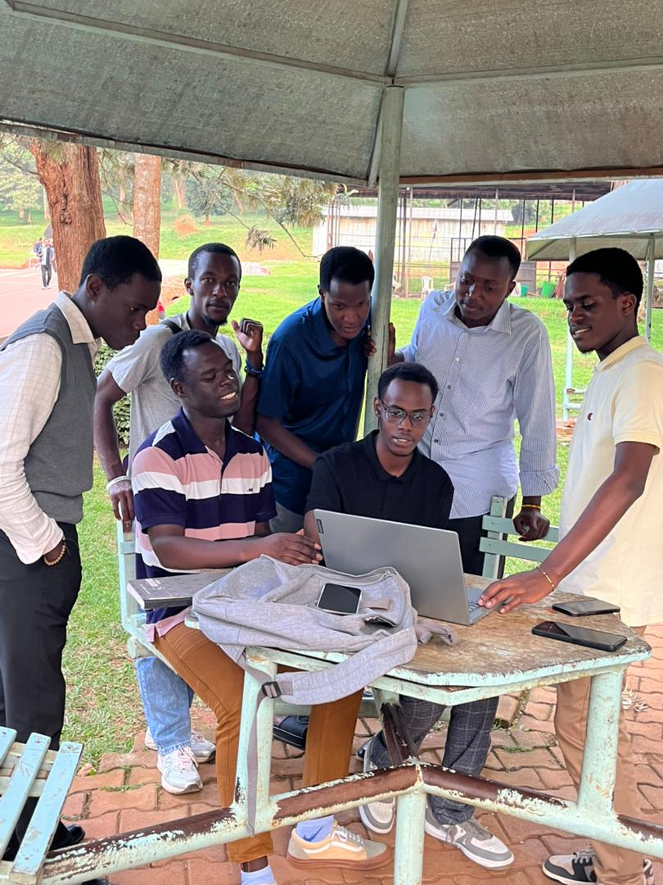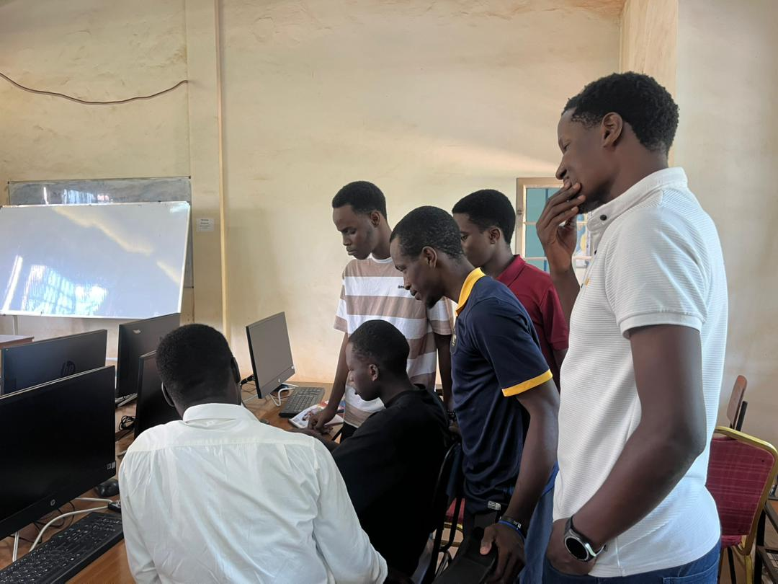

**CONCLUSION**

**The study concludes that the average UCU student studies about four hours per day. While most students maintain a consistent schedule, some show very low or very high study times. We recommended that students develop balanced study routines and utilize library resources effectively. Further research could compare study hours with academic performance to identify deeper trends.**

|  |  |  |
| --- | --- | --- |
| **GROUP MEMBERS** | **STUDENT_ID** | **CONTRIBUTION** |
| **MALISH EMMANUEL ABUI** | **M25B13/032** | **Questionnaire design.** |
| **MUGISHA ALVIN** |  | **chart generation** |
| **MUGISHA AMOS** | **M25B13/028** | **Report writing, formatting** |
| **KAYEMBA ISAAC FRANK** | **M25B13/O42** | **data verification** |
| **NYAKAANA CEDRIC CHARLES** | **M25B13/036** | **Quality assurance, editing** |
| **MUKISA JOEL** | **M25B13/008** | **field data collection** |

**QUESTIONS**

**1.WHAT IS THE PROBABILY THAT LAW STUDENTS SPEND MORE HOURS STUDYING COMPARED TO OTHER STUDENTS**

**Total law students=`13**

**Mean of law students**

Sum = 10 + 2 + 15 + 12 + 10 + 15 + 10 + 8 + 10 + 8 + 7 + 12 + 10 = **129**  
Average = 129 / 13 = **9.92 hours/day**

**Other students spent =6.00-7.00 hours a day**

**2.WHAT IS THE AVERAGE NUMBER OF STUDENTS THAT USE THE LIBRARY?**

**Average= number of students who use the library/total number of students x100**

**=(39/63)*100**

**AVERAGE =61.9%**

**3.WHAT IS THE AVERAGE TIME(HRS) A BSIT STUDENT SPENDS READING IN A DAY?**

Mean=Number of students/Sum of hours​

BSIT students=19

Sum of hours=Sum = 5 + 4 + 4 + 5 + 4 + 7 + 7 + 4 + 8 + 4 + 4 + 5 + 8 + 4 + 8 + 6 + 8 + 8 + 4 = **109**

Average=109/19=5.74 hours per day

**4.WHAT ARE THE FACTORS THAT AFFECT STUDING HOURS OF STUDENTS?**

|  |
| --- |
| Comment on factors that affect your study hours: |
| Laziness |
| The number of lecturers i study in a day  The amount of coursework i am given |
| Lecturers not being stable. One day they want to teach online and other times physically. And they communicate later(after you’ve moved to school ) |
|  |
| Coldness |
| 8 am class!! |
| Internet |
| Electricity availability |
| Hunger |
| Fixed time table |
| Part time work |
| Upcoming tests |
| Mood. It determines how much I can perceive. |
| Hunger😂 |
| TikTok 😭 |
| Tiredness |
| Work |
| Gadgets |
| Commuting |
|  |
| Sleep |
| Tik tok Manga fox |
| Noise |
| Procrastination  Peer influence Naps Noisy environment |
| Tiktok |
|  |
| My mood My attitude  Weather conditions  Amount of pressure on me |
|  |
| Sleep |
| Laziness |
| Friday mostly affects it |
|  |
| Lecture hours |
| Sleep, friends |
| Social media |
| Social media |
| Random Lectures |
| social media |
| Nothing |
| Co curricular activities |
| Laziness |
| Distance |
| Company of friends |
| Pashhhhh |
| Internet speed |
| Solitude and discipline |
| Random lectures |
| Emerging programs  Hanging out |
|  |
| Sleep and procrastination |
| Resting time |
| Fatigue from the day |
| The internet |
| Rain |
| Body state |
| The morning lecturers are stressing |
| Relationships |
| Sleep |
| Procrastination |
| Laziness |
|  |
| This telephoneeeee |
| No Internet connection |

**FACTORS LIMITING**

Laziness